“Harrison Bergeron” and 2081 Compare and Contrast
(Small Groups of 3)
1. Create a venn diagram comparing the short story “Harrison Bergeron” and the short film 2081. List at least FOUR likenesses and FOUR differences. (Items on the outside / the differences should be lined up and related to one another.)
Choose ONE difference and ONE similarity from your chart and write the following paragraphs. BE SURE to select something that is SIGNFICANT.

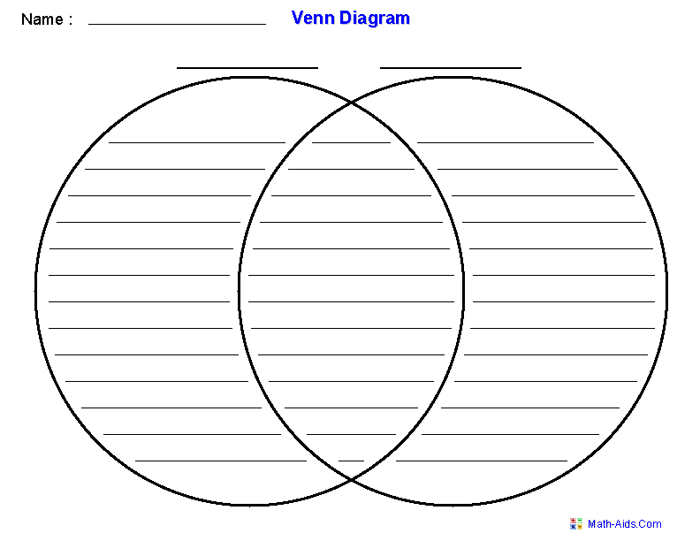

2. In paragraph #1 discuss the similarity you chose and WHY IT WAS
IMPORTANT FOR THE FILMMAKER TO KEEP THIS ELEMENT IN THE MOVIE. You must include a QUOTE from the story and a specific example from the film to backup your statement. Why was this story element interesting, important, and powerful??? (AVOID saying things like it made it more interesting, etc. BE SPECIFIC about how this impacted the plot.)
____________________________________________________________________________________________________________________________________________________________________________________________________________________________________________________________________________________________________________________________________________________________________________________________________________________________________________________________________________________________________________________________________________________________________________________________________________

3. In paragraph #2 discuss the difference you selected and explain
HOW THE CHANGE IN THE MOVIE ALTERED YOUR VIEW OF THE SOCIETY OR CHARACTERS. You must include a QUOTE from the story and a specific example from the film to backup your statement.
____________________________________________________________________________________________________________________________________________________________________________________________________________________________________________________________________________________________________________________________________________________________________________________________________________________________________________________________________________________________________________________________________________________________________________________________________________

4. In paragraph #3 EVALUATE. Did you like the movie or the short story version better? Be specific about how the change impacted character or plot development. (If you say the movie was more visual you will get a ZERO for this question! All movies are more visual. The explanation needs to be SPECIFIC and demonstrate the impact of the DECISIONS the director &/OR author made)
____________________________________________________________________________________________________________________________________________________________________________________________________________________________________________________________________________________________________________________________________________________________________________________________________________________________________________________________________________________________________________________________________________________________________________________________________________
Note: “Harrison Bergeron” in quotes / 2081 underlined or in italics

